Team Evaluation

1. Brendan Rizzo
   1. Worked on Question 1 and came up with a great answer
2. Richard Huang
   1. Richard solved question 2 with little help by Eden.
3. Jiashang Cao
   1. I don’t know where Jiashang went.
4. **Eden Seo**
   1. Helped Richard little bit on solving question 2.
5. Question 1 (Exercise 3.6 in LFD)
   1. 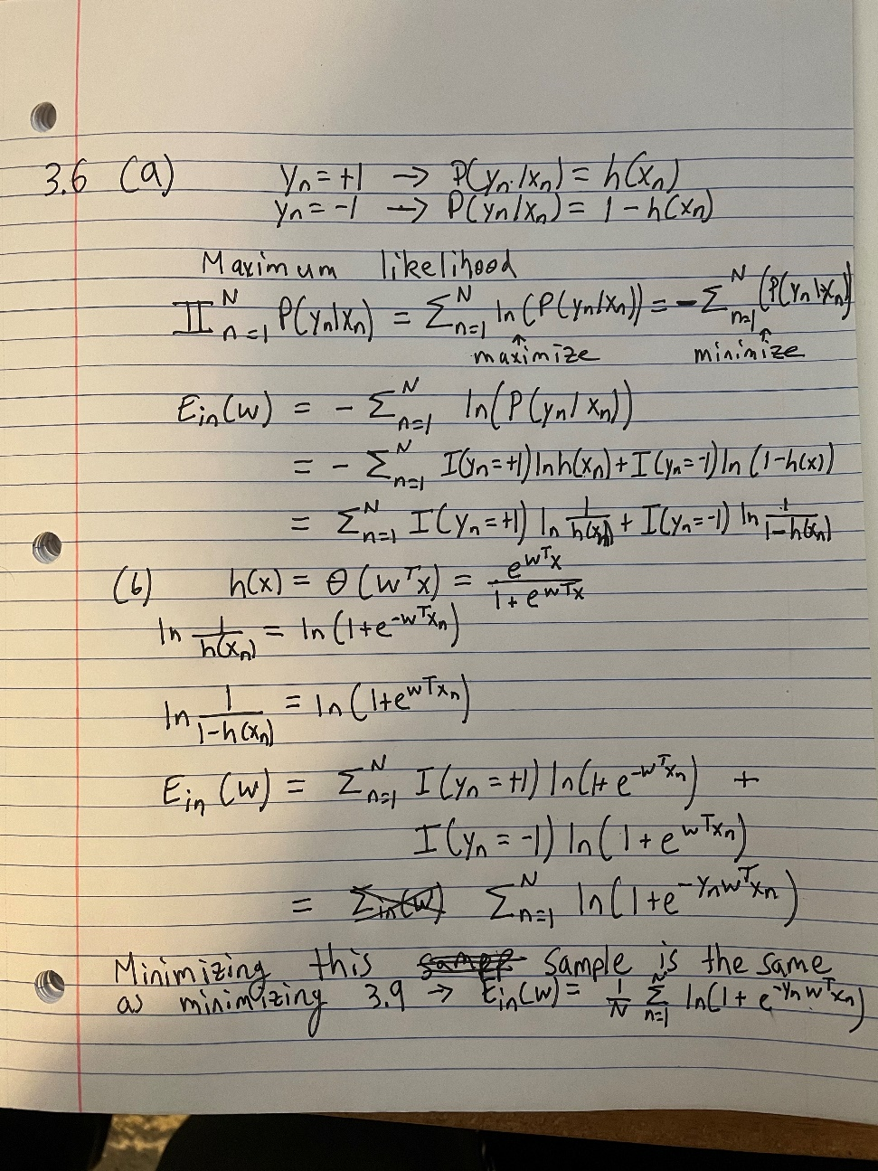
6. Question 2 (Exercise 3.7 in LFD)
   1. 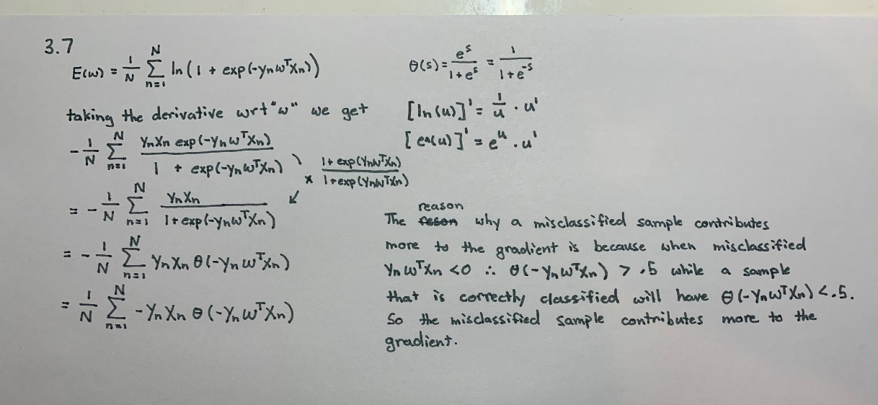
7. Question 3
   1. 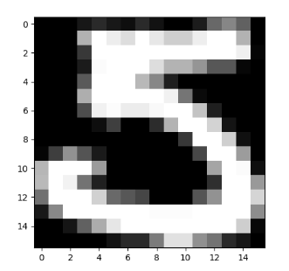 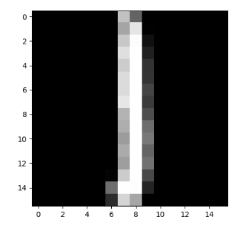 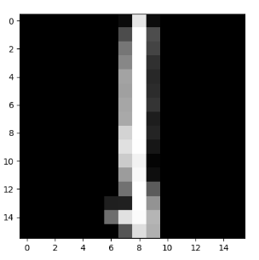 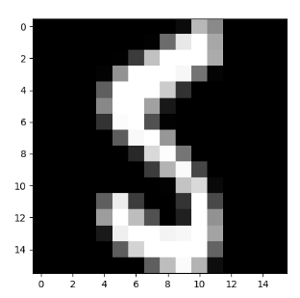
   2. Intensity of One: [-0.7539140625, -0.77228125, … -0.44755859374999996]  
      Intensity of Five: [-0.11173828124999999, -0.56403515625, … -0.53423828125]  
      Symmetry of One: [0.029765625, 0.035273437500000004, … 0.04910546875]  
      Symmetry of Five: [0.42023828124999996, 0.21845703125, … 0.29608203125]
      1. If you run the code, you’ll see the whole values.
   3. 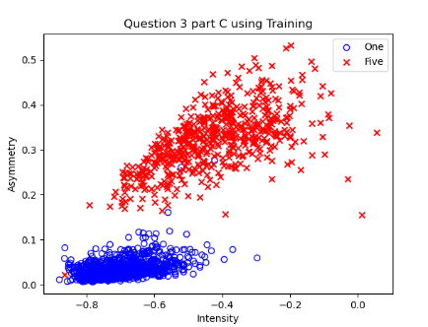
8. Question 4
   1. 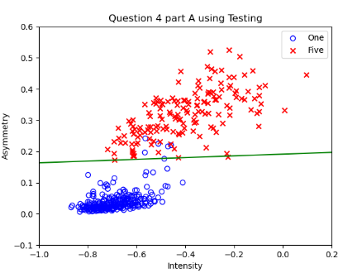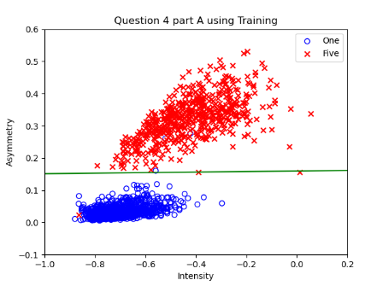
   2. 
   3. 
   4. We should not use 3rd order transform since it has higher E values than the original